Item nummer | Quantity | Product | Photo | RRP | Stock Price | Stock Take All
P705.651 | 1087 | Bobby Compact print Black | 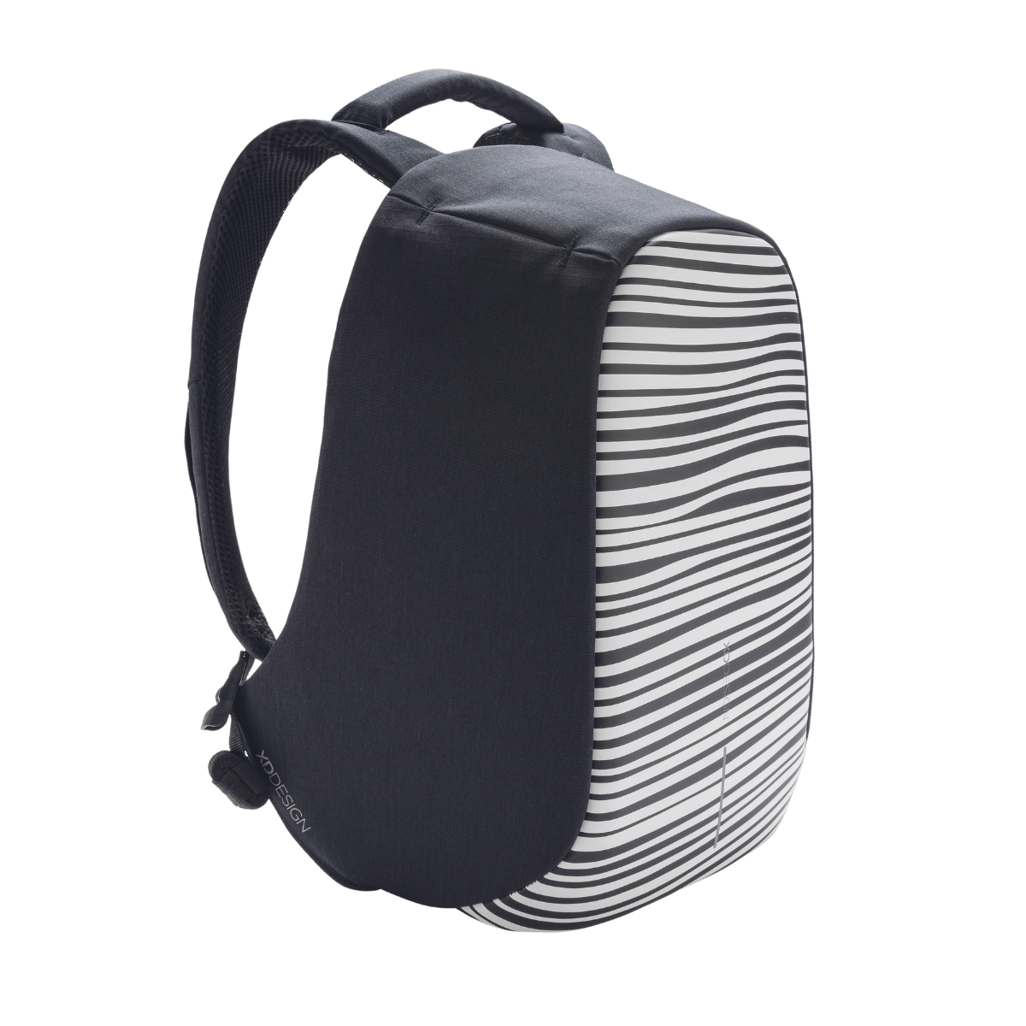 | 94,95
P705.655 | 724 | Bobby Compact print Blue | 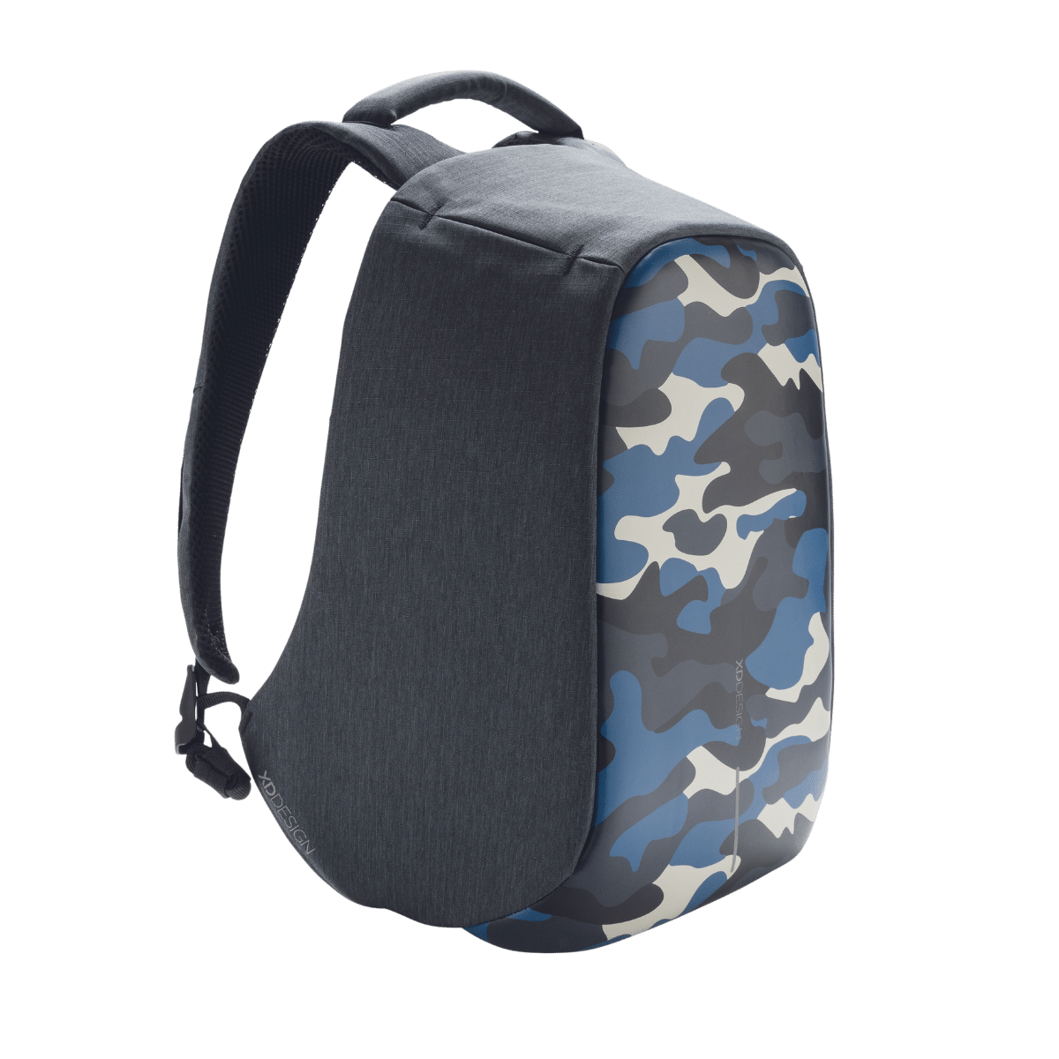 | 94,95
P705.251 | 159 | Bobby Tech Black | 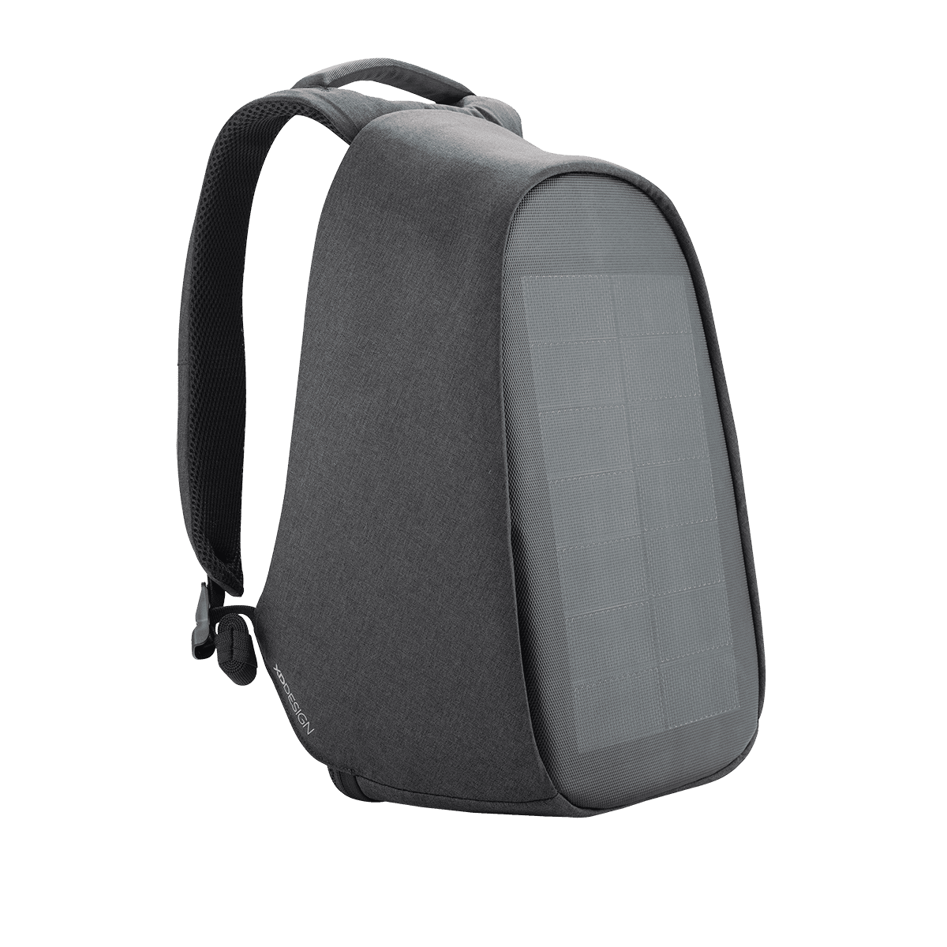 | 229,95
P705.229 | 345 | Elle Fashion Blue | 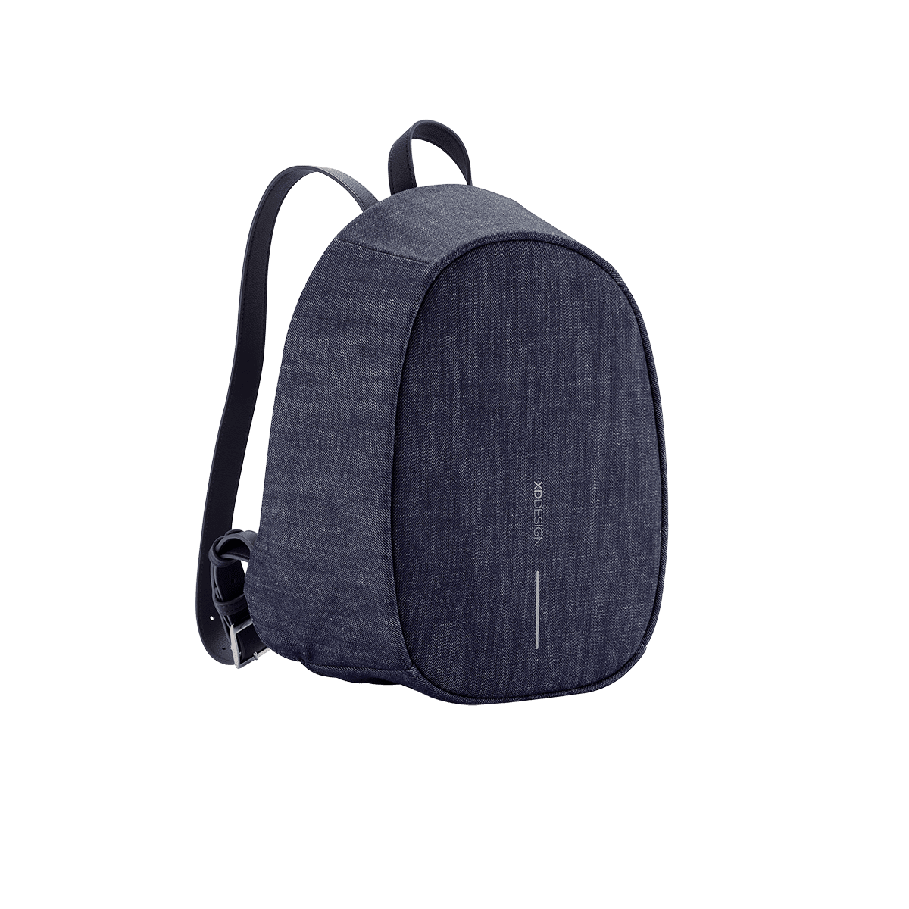 | 79,95
P705.220 | 290 | Elle Fashion Grey | 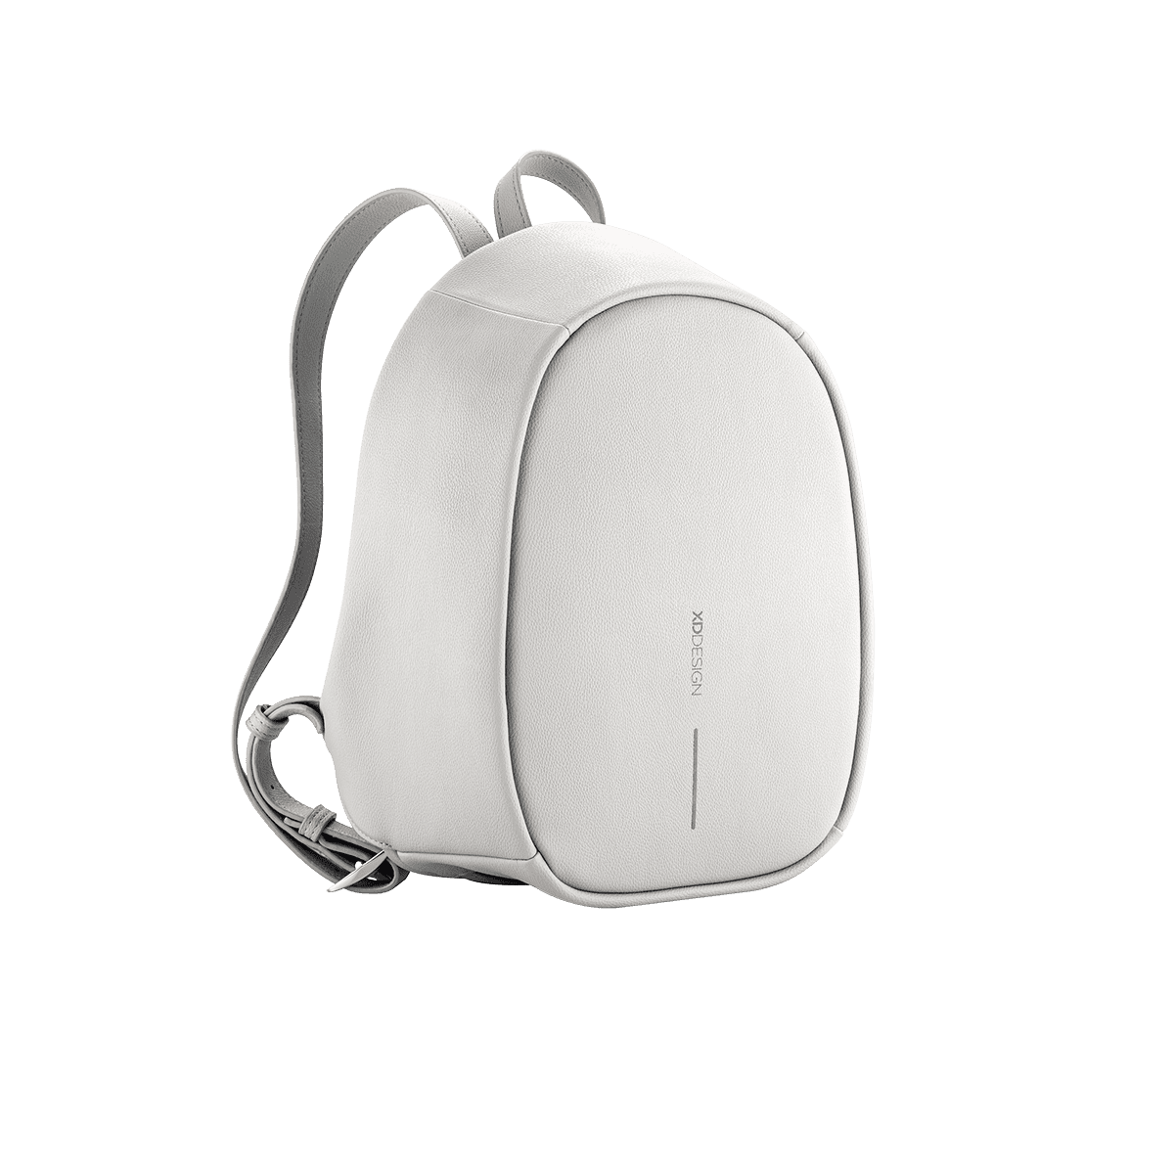 | 79,95
P705.535 | 9 | Bobby Compact blue | 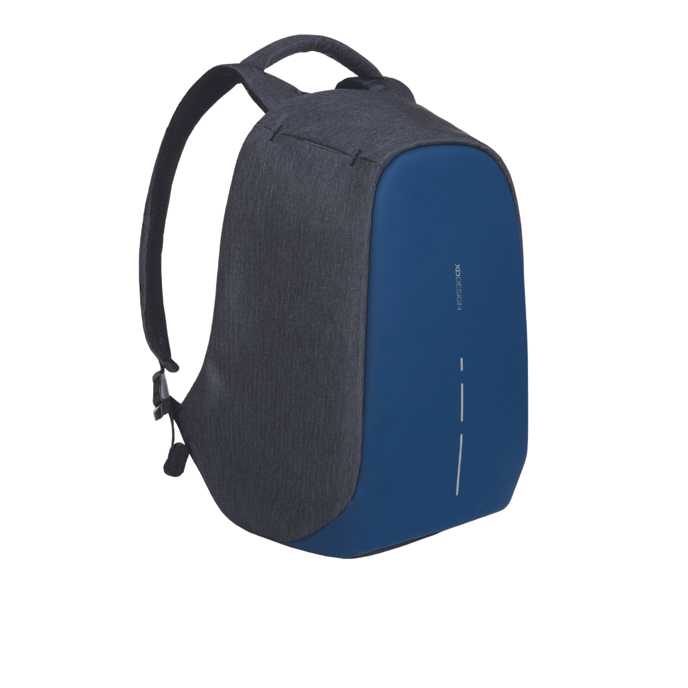 | 94,95
P705.537 | 171 | Bobby Compact Green | 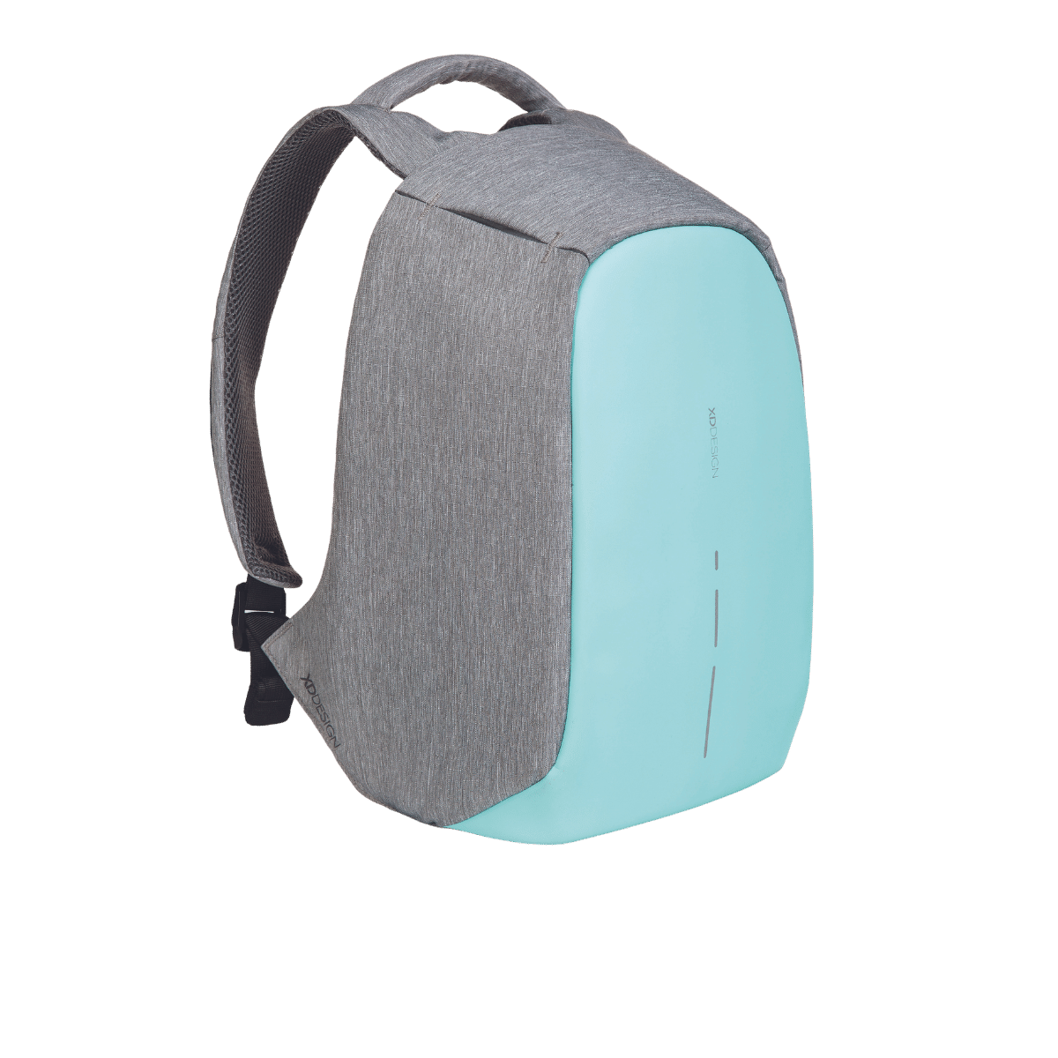 | 94,95
P705.657 | 273 | Bobby Compact print Green | 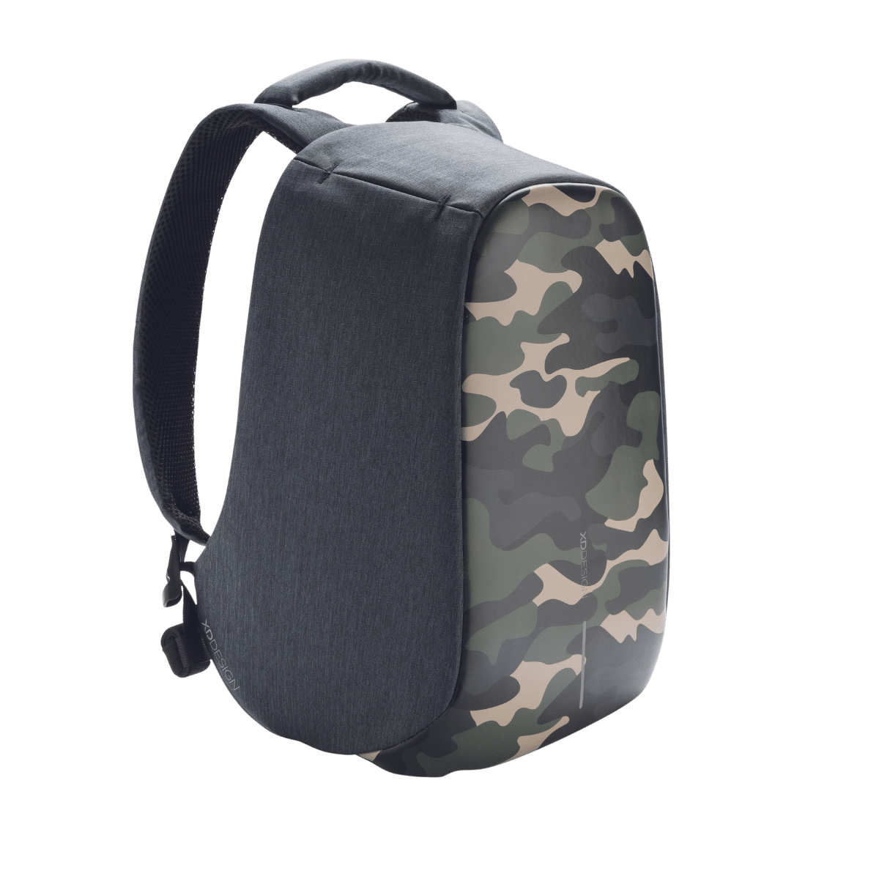 | 94,95

